 | Student Name _______________________  Eastern Goldfields College  Unit 3/4 Essentials Mathematics 2017  Application 1 – Layton’s Feature Circle
Class time allocated: 90 minutes Weighting 8% Total Marks: 40

Layton has just moved into a new house and is looking at landscaping his backyard. He wants a circular brick-paved feature within his garden. Around the feature he wishes to have a row of cobblestones as a border.

Layton needs some help to decide what size his brick-paved feature should be and to work out how much it is going to cost.

ROUND YOUR ANSWERS TO 3 DECIMAL PLACES

1. [2 marks]
Calculate the circumference of a circle with radius 0.5 m.

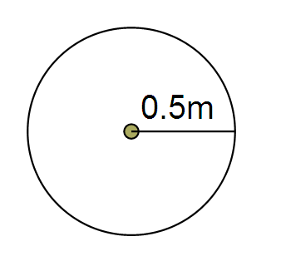

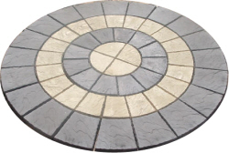

2. [2 marks]
Calculate the area of a circle with radius 0.5 m.

3. [2 marks]

- Which measurement best describes the amount of cobblestones required? (Please circle)

CIRCUMFERENCE AREA

- Which measurement best describes the amount of bricks required? (Please circle)

CIRCUMFERENCE AREA

Layton would like to investigate different possible sizes for his feature.

4. [1, 1, 1 = 3 marks]
Calculate the circumference of each circle below.
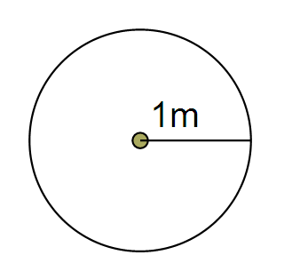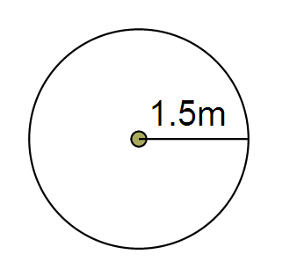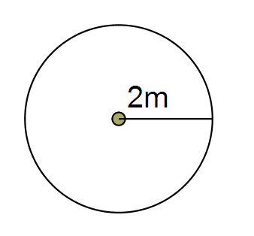
(a) (b) (c)

5. [1 mark]
Use your answers from questions 1 and 4 to complete the table below.

Radius of Circle  (m) | Circumference of Circle  (m)

6. [2 marks]
When the radius of a circle is doubled, does the circumference also double? (Show evidence/calculations to support you answer.)

7. [2 marks]
When the radius of a circle is tripled (three times as long), what happens to the circumference? Does it also triple? (Show evidence/calculations to support you answer.)

8. [1, 1, 1 = 3 marks]
Calculate the area of each circle below.
(a) (b) (c)

9. [1 mark]
Use your answers from questions 2 and 8 to complete the table below.

Radius of Circle  (m) | Area of Circle  (m²)

10. [3 marks]
When the radius of a circle is doubled, does the area also double? (Show evidence/calculations to support you answer.) If not what is happening?

11. [3 marks]
When the radius of a circle is tripled (three times as long), what happens to the area? Does it also triple? (Show evidence/calculations to support you answer.) If not what is happening?

Price List

Brick Pavers (feature) $65 per m²
Cobblestones (border) $9.50 per 1m of border

12. [3 marks]
Layton decides to make a circular feature with a radius of 1m. Using the price list above, how much will Layton’s feature cost in total?

- [2 marks]
Layton then realises that he could afford to build a bigger feature. He decides to double the radius. Without doing calculations, do you think that the new cost will be

  - less than double the original cost?

  - exactly double the original cost?

  - More than double the original cost?

[Circle correct answer]

Explain your choice.

- [3 marks]
Calculate the total cost of the new feature (with the doubled radius).

- [2 marks]
Is the new cost less than, more than or exactly double the original cost? (Show evidence/calculations to support your answer).

50 cm
50 cm
50 cm
50 cm

16. [4 marks]
For the design above calculate the area to be paved by the light coloured pavers.

17. [2 marks]
What percentage of the design will be covered by the light pavers?

